THREE CUPS OF TEA
ONE MAN’S MISSION TO FIGHT TERRORISM AND
BUILD NATIONS… ONE SCHOOL AT A TIME
GREG MORTENSON and DAVID OLIVER RELIN
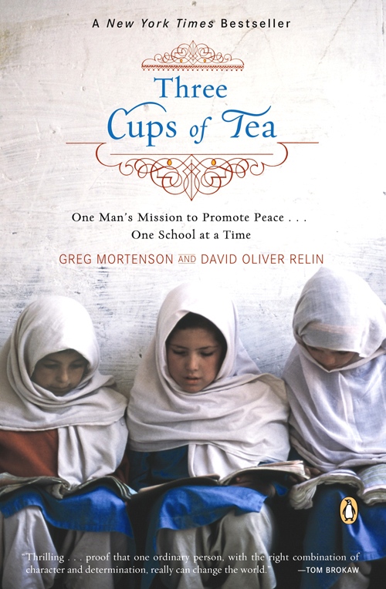

http://libraryindus.files.wordpress.com/2011/09/three-cups-of-tea.pdf
INTRODUCTION
IN MR. MORTENSON’S ORBIT
The little red light had been flashing for five minutes before Bhangoo paid it any attention. “The fuel gages on these old aircraft are notoriously unreliable,” Brigadier General Bhangoo, one of Pakistan’s most experienced high-altitude helicopter pilots, said, tapping it. I wasn’t sure if that was meant to make me feel better.
I rode next to Bhangoo, looking down past my feet through the Vietnam-era Alouette’s bubble windshield. Two thousand feet below us a river twisted, hemmed in by rocky crags jutting out from both sides of the Hunza Valley. At eye level, we soared past hanging green glaciers, splintering under a tropical sun. Bhangoo flew on unperturbed, flicking the ash of his cigarette out a vent, next to a sticker that said “No smoking.”
From the rear of the aircraft Greg Mortenson reached his long arm out to tap Bhangoo on the shoulder of his flight suit. “General, sir,” Mortenson shouted, “I think we’re heading the wrong way.”
Brigadier Bhangoo had been President Musharraf’s personal pilot before retiring from the military to join a civil aviation company. He was in his late sixties, with salt-and-pepper hair and a mustache as clipped and cultivated as the vowels he’d inherited from the private British colonial school he’d attended as boy with Musharraf and many of Pakistan’s other future leaders.
The general tossed his cigarette through the vent and blew out his breath. Then he bent to compare the store-bought GPS unit he balanced on his knee with a military-grade map Mortenson folded to highlight what he thought was our position.
“I’ve been flying in northern Pakistan for forty years,” he said, waggling his head, the subcontinent’s most distinctive gesture. “How is it you know the terrain better than me?” Bhangoo banked the Alouette steeply to port, flying back the way we’d come.
The red light that had worried me before began to flash faster. The bobbing needle on the gauge showed that we had less than one hundred liters of fuel. This part of northern Pakistan was so remote and inhospitable that we’d had to have friends preposition barrels of aviation fuel at strategic sites by jeep. If we couldn’t make it to our drop zone we were in a tight spot, literally, since the craggy canyon we flew through had no level areas suitable for setting the Alouette down.
Bhangoo climbed high, so he’d have the option of auto-rotating toward a more distant landing zone if we ran out of fuel, and jammed his stick forward, speeding up to ninety knots. Just as the needle hit E and the red warning light began to beep, Bhangoo settled the skids at the center of a large H, for helipad, written out in white rocks, next to our barrels of jet fuel.
“That was a lovely sortie,” Bhangoo said, lighting another cigarette. “But it might not have been without Mr. Mortenson.”
Later, after refueling by inserting a handpump into a rusting barrel of aviation fuel, we flew up the Braldu Valley to the village of Korphe, the last human habitation before the Baltoro Glacier begins its march up to K2 and the world’s greatest concentration of twenty-thousand-foot-plus peaks. After a failed 1993 attempt to climb K2, Mortenson arrived in Korphe, emaciated and exhausted. In this impoverished community of mud and stone huts, both Mortenson’s life and the lives of northern Pakistan’s children changed course. One evening, he went to bed by a yak dung fire a mountaineer who’d lost his way, and one morning, by the time he’d shared a pot of butter tea with his hosts and laced up his boots, he’d become a humanitarian who’d found a meaningful path to follow for the rest of his life.
Arriving in Korphe with Dr. Greg, Bhangoo and I were welcomed with open arms, the head of a freshly killed ibex, and endless cups of tea. And as we listened to the Shia children of Korphe, one of the world’s most impoverished communities, talk about how their hopes and dreams for the future had grown exponentially since a big American arrived a decade ago to build them the first school their village had ever known, the general and I were done for.
“You know,” Bhangoo said, as we were enveloped in a scrum of 120 students tugging us by the hands on a tour of their school, “flying with President Musharraf, I’ve become acquainted with many world leaders, many outstanding gentlemen and ladies. But I think Greg Mortenson is the most remarkable person I’ve ever met.”
Everyone who has had the privilege of watching Greg Mortenson operate in Pakistan is amazed by how encyclopedically well he has come to know one of the world’s most remote regions. And many of them find themselves, almost against their will, pulled into his orbit. During the last decade, since a series of failures and accidents transformed him from a mountaineer to a humanitarian, Mortenson has attracted what has to be one of the most underqualified and overachieving staffs of any charitable organization on earth.
Illiterate high-altitude porters in Pakistan’s Karakoram have put down their packs to make paltry wages with him so their children can have the education they were forced to do without. A taxi driver who chanced to pick Mortenson up at the Islamabad airport sold his cab and became his fiercely dedicated “fixer.” Former Taliban fighters renounced violence and the oppression of women after meeting Mortenson and went to work with him peacefully building schools for girls. He has drawn volunteers and admirers from every stratum of Paki-stan’s society and from all the warring sects of Islam.
Supposedly objective journalists are at risk of being drawn into his orbit, too. On three occasions I accompanied Mortenson to northern Pakistan, flying to the most remote valleys of the Karakoram Himalaya and the Hindu Kush on helicopters that should have been hanging from the rafters of museums. The more time I spent watching Mortenson work, the more convinced I became that I was in the presence of someone extraordinary.
The accounts I’d heard about Mortenson’s adventures building schools for girls in the remote mountain regions of Pakistan sounded too dramatic to believe before I left home. The story I found, with ibex hunters in the high valleys of the Karakoram, in nomad settlements at the wild edge of Afghanistan, around conference tables with Pakistan’s military elite, and over endless cups of paiyu cha in tearooms so smoky I had to squint to see my notebook, was even more remarkable than I’d imagined.
As a journalist who has practiced this odd profession of probing into people’s lives for two decades, I’ve met more than my share of public figures who didn’t measure up to their own press. But at Korphe and every other Pakistani village where I was welcomed like long-lost family, because another American had taken the time to forge ties there, I saw the story of the last ten years of Greg Mortenson’s existence branch and fork with a richness and complexity far beyond what most of us achieve over the course of a full-length life.
This is a fancy way of saying that this is a story I couldn’t simply observe. Anyone who travels to the CAI’s fifty-three schools with Mortenson is put to work, and in the process, becomes an advocate. And after staying up at all-night jirgas with village elders and weighing in on proposals for new projects, or showing a classroom full of excited eight-year-old girls how to use the first pencil-sharpener anyone has ever cared to give them, or teaching an impromptu class on English slang to a roomful of gravely respectful students, it is impossible to remain simply a reporter.
As Graham Greene’s melancholy correspondent Thomas Fowler learned by the end of The Quiet American, sometimes, to be human, you have to take sides.
I choose to side with Greg Mortenson. Not because he doesn’t have his flaws. His fluid sense of time made pinning down the exact sequence of many events in this book almost impossible, as did interviewing the Balti people with whom he works, who have no tenses in their language and as little attachment to linear time as the man they call Dr. Greg.
During the two years we worked together on this book, Mortenson was often so maddeningly late for appointments that I considered abandoning the project. Many people, particularly in America, have turned on Mortenson after similar experiences, calling him “unreliable,” or worse. But I have come to realize, as his wife Tara Bishop often says, “Greg is not one of us.” He operates on Mortenson Time, a product, perhaps, of growing up in Africa and working much of each year in Pakistan. And his method of operation, hiring people with limited experience based on gut feelings, forging working alliances with necessarily unsavory characters, and, above all, winging it, while unsettling and unconventional, has moved mountains.
For a man who has achieved so much, Mortenson has a remarkable lack of ego. After I agreed to write this book, he handed me a page of notepaper with dozens of names and numbers printed densely down the margin in tiny script. It was a list of his enemies. “Talk to them all,” he said. “Let them have their say. We’ve got the results. That’s all I care about.”
I listened to hundreds of Mortenson’s allies and enemies. And in the interest of security and/or privacy I’ve changed a very few names and locations.
Working on this book was a true collaboration. I wrote the story. But Greg Mortenson lived it. And together, as we sorted through thousands of slides, reviewed a decade’s worth of documents and videos, recorded hundreds of hours of interviews, and traveled to visit with the people who are central to this unlikeliest of narratives, we brought this book to life.
And as I found in Pakistan, Mortenson’s Central Asia Institute does, irrefutably, have the results. In a part of the world where Americans are, at best, misunderstood, and more often feared and loathed, this soft-spoken, six-foot-four former mountaineer from Montana has put together a string of improbable successes. Though he would never say so himself, he has single-handedly changed the lives of tens of thousands of children, and independently won more hearts and minds than all the official American propaganda flooding the region.
So this is a confession: Rather than simply reporting on his progress, I want to see Greg Mortenson succeed. I wish him success because he is fighting the war on terror the way I think it should be conducted. Slamming over the so-called Karakoram “Highway” in his old Land Cruiser, taking great personal risks to seed the region that gave birth to the Taliban with schools, Mortenson goes to war with the root causes of terror every time he offers a student a chance to receive a balanced education, rather than attend an extremist madrassa.
If we Americans are to learn from our mistakes, from the flailing, ineffective way we, as a nation, conducted the war on terror after the attacks of 9/11, and from the way we have failed to make our case to the great moderate mass of peace-loving people at the heart of the Muslim world, we need to listen to Greg Mortenson. I did, and it has been one of the most rewarding experiences of my life.
—David Oliver Relin Portland, Oregon
5

