Police Chief in Florida Tries to Ease Old Tensions
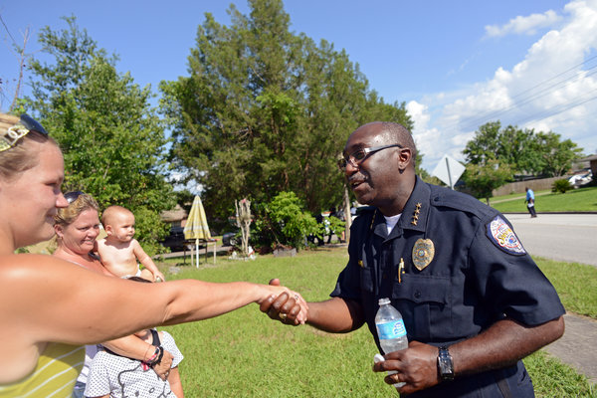
Sarah Beth Glicksteen for The New York Times
Cecil Smith, the new police chief in Sanford, Fla., greeting residents during a community outreach initiative.

By CARA BUCKLEY

Published: June 16, 2013

SANFORD, Fla. — Within days of becoming the police chief in this small city outside Orlando, Cecil E. Smith began to see clearly the scope of the challenges he faced.
There were grumblings within the Police Department’s ranks: at least one supervisor said he did not want to work for a black man.
Out on the streets, some black residents voiced misgivings of a different sort. Chief Smith may be black, but he is a Northerner. How could he ever understand them?
“This has been a slave town forever,” one resident said to Chief Smith in a low voice. “There are people who still feel white people are the devil. You’re not from here. You don’t understand.”
Peering through his glasses, Chief Smith locked eyes with the man, he later recalled. “Enlighten me,” he said, “so I can enlighten my people.”
The department Chief Smith now leads and the city it serves are in the arduous stages of trying to integrate lessons drawn from the episode that brought infamy to Sanford 16 months ago. The fatal shooting of Trayvon Martin, an unarmed black teenager, by George Zimmerman, a volunteer neighborhood watchman, compelled many to assert that racial profiling and citizen vigilantism had taken place.
Sandford’s Police Department became the focus of much of the rage. That the agency neither arrested nor charged Mr. Zimmerman, who claimed self-defense, was taken by some as proof of not only ineptness but also bias.
This seemed especially true after a special prosecutor, appointed by the governor, charged Mr. Zimmerman with second-degree murder more than six weeks after the shooting. Had Mr. Zimmerman, who is Hispanic, been black, many believed, he would not have been released on claims of self-defense. His trial began here with jury selection last week.
Since the shooting, city officials and religious leaders have labored to soothe tensions. The police chief who oversaw the Zimmerman case, Bill Lee, was fired. An interfaith coalition of ministers was formed. The city asked the Justice Department to review the Police Department’s practices — the request was turned down, at least for now — and a panel of community leaders was assembled to assess relations between the public and the police.
But the biggest hurdle remains: decades of animus between black residents and the Police Department.
“The black community, they don’t trust the Sanford police,” said Turner Clayton Jr., the president of the Seminole County N.A.A.C.P. “They trust the Sheriff’s Office and any other agency more.”
Responsibility for mending relations has largely fallen on the shoulders of Chief Smith, 52, a balding, soft-spoken man of medium build from Chicago’s West Side.
Before besting 75 other candidates for the job, which he began on April 1, Chief Smith spent his previous 26 years in law enforcement in Elgin, Ill., where he investigated drugs and gangs, worked in community relations and rose to deputy chief. His own family is a picture of diversity. He and his wife of 15 years, who is white, have parented five children between them, and one of his goddaughters is a lesbian.
After arriving in Sanford, Chief Smith deployed strategies he honed in Elgin. At community events, he doles out hugs. Every Thursday afternoon, he and a dozen or so officers go door to door in a different neighborhood — introducing themselves with smiles, pumping hands, scribbling down names and numbers, and asking if there are problems that the police can address.
This outreach has left residents both astounded and delighted. “I’ve been here 30 years, and I didn’t know you did this,” one woman said during an outing last week.
The chief has also been spotted in plain clothes late at night chatting with people in Goldsboro, a historic black neighborhood. “I saw him mingling with teenagers,” said Cindy Philemon, who works in Goldsboro. “All I could do was smile. My heart was filled with joy. Before, it was like neglect.”
But local black leaders say it is too early to deem Chief Smith’s leadership a success, especially because the department remains more or less unchanged.
“Two months won’t take away six decades — it just can’t,” said Kenneth Bentley, a community activist and educator. “At the end of the day, he’s still chief over those officers that have the same mentality.”
While the enmity toward the police is rooted in Sanford’s segregationist past, black residents and leaders said it had been fueled by what they described as mistreatment and the agency’s failure to thoroughly investigate the shooting deaths of many young black men — an assertion that the police dispute.
“The Trayvon Martin case just happened to bring it to a boiling point,” said Velma Williams, the city’s only black commissioner. “Those feelings have been there long before.”
Chief Smith said he was addressing any hints of bias in his department. After learning of the supervisor who complained about his appointment, Chief Smith called a meeting. “I was informed someone didn’t want to work for a black chief,” he recalled telling the quiet room. “If you don’t want to work for me, there’s the door.”
He recently appointed a longtime Sanford law enforcement officer, Darren Scott, who is black, as his deputy. Chief Smith is not the department’s first black leader, but this is the first time people can recall two black men holding the department’s top spots. Just over half of Chief Smith’s officers are white men, and he is seeking more diversity in recruits.
City leaders, including Ms. Williams, insist that they have faith in the new chief. Mayor Jeff Triplett said, “This guy is highly focused on rebuilding that trust, doing what’s right for the community.” He added, “I don’t see him stopping.”
Restoring trust, the mayor said, “was the main crux of what we thought we needed to repair.”
Still, critics questioned the staying power of the department’s outreach efforts once the Zimmerman trial ends and the intense national attention drifts. Promises and efforts made before, they said, have all sputtered out.
At the very least, some residents say the aftermath of Mr. Martin’s shooting forced city leaders to take a hard look at issues that many felt had gone unaddressed for too long.
“The untold story of Sanford would never have been told,” said Mr. Bentley, the community activist, “if one person had let another person walk through the neighborhood.”

A version of this article appeared in print on June 17, 2013, on page A9 of the New York edition with the headline: Police Chief In Florida Tries to Ease Old Tensions.

