Evidence mixed for Zimmerman’s self-defense claim

Original lead detective in the case believed Zimmerman caused the fight that erupted between him and unarmed teen Trayvon Martin

By The Associated Press / NEW YORK DAILY NEWS

Friday, May 18, 2012, 7:17 AM
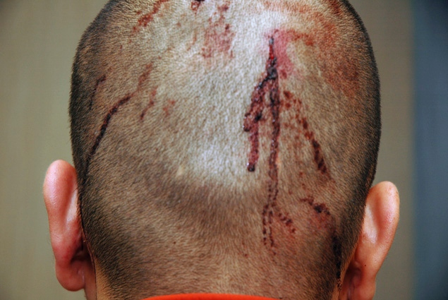

State Attorney's Office/AP
This Feb. 27, 2012 photo released by the State Attorney's Office shows George Zimmerman, the neighborhood watch volunteer who shot Trayvon Martin, with blood on the back of his head. The photo and reports were among evidence released by prosecutors that also includes calls to police, video and numerous other documents. The package was received by defense lawyers earlier this week and released to the media on Thursday, May 17, 2012.

ORLANDO, Fla. — When George Zimmerman tries to convince a judge or jury that he shot Trayvon Martin in self-defense, the evidence he’ll be able to call on appears to be a mixed bag.
More than 200 pages of photos and eyewitness accounts released by prosecutors Thursday show Zimmerman and Martin were in a loud and bloody fight in the moments leading up to the shooting and that Zimmerman appeared to be getting the worst of it, with wounds both to his face and the back of his head.
But the original lead detective in the case believed Zimmerman caused the fight by getting out of his vehicle to confront Martin, who wasn’t doing anything criminal, and then could have defused the situation by telling Martin he was just a concerned citizen and tried to talk to him. He didn’t think Zimmerman could legally invoke Florida’s “stand your ground” law and should be charged with manslaughter.
Under that law, people are given wide latitude to use deadly force rather than retreat in a fight if they believe they are in danger of being killed or seriously injured, they weren’t committing a crime themselves and are in a place they have the legal right to be. The original prosecutor in the case accepted Zimmerman’s invocation of the law after the Feb. 26 shooting but a special prosecutor rejected his claim last month and charged Zimmerman with second-degree murder. The former neighborhood watch volunteer has pleaded not guilty, has been released on bail and reportedly is in hiding.
He and his attorney will have two more chances to invoke the law. First, they will try to convince a judge during what will be a mini-trial. If the judge agrees, the charges will be dropped although prosecutors could appeal. That is likely months away. If the judge rejects the claim, Zimmerman could they try to convince the jury and win an acquittal. A trial is unlikely to start before next year. Zimmerman’s attorney, Mark O’Mara, didn’t return a phone call seeking comment Thursday.
Joelle Moreno, a Florida International University law school professor, said the evidence now released makes it difficult to predict if that defense will work. She is a member of a state senator’s task force examining the law.
Larry Kobilinsky, professor of forensic science at John Jay College of Criminal Justice in New York, said that after reviewing the evidence, he thinks Zimmerman is in a good position.
“I think the prosecution’s case has been seriously diminished by all of this evidence,” he said.
Still, many of the pertinent questions remain unclear: What was in Zimmerman’s mind when he began to follow Martin in the gated community where he lived? How did the confrontation between the two begin? Whose screams for help were captured on 911 calls? And why did Zimmerman feel that deadly force was warranted? Did the fact that Martin was black play a role in Zimmerman’s actions?
The evidence supporting Zimmerman’s defense includes a photo showing the neighborhood watch volunteer with a bloody nose on the night of the fight. A paramedic report says Zimmerman had a 1-inch laceration on his head and forehead abrasion.
“Bleeding tenderness to his nose, and a small laceration to the back of his head. All injuries have minor bleeding,” paramedic Michael Brandy wrote about Zimmerman’s injuries in the report.
But other evidence supports the contention of Martin’s parents that Zimmerman was the aggressor.
The investigator who called for Zimmerman’s arrest, Christopher Serino, told prosecutors the fight could have been avoided if Zimmerman had remained in his vehicle and awaited the arrival of law enforcement. He said Zimmerman, after leaving his vehicle, could have identified himself to Martin as a concerned citizen and talked to him instead of confronting him. The report was written March 13, nearly a month before Zimmerman’s eventual arrest.
He said there is no evidence Martin was involved in any criminal activity as he walked from a convenience store to the home of his father’s fiance in the same gated community where Zimmerman lived.
The lawyer for Martin’s parents seized on the investigator’s recommendation.
“The police concluded that none of this would have happened if George Zimmerman hadn’t gotten out of his car,” said attorney Ben Crump. “If George Zimmerman hadn’t gotten out of his car, they say it was completely avoidable. That is the headline.”
The release of evidence did little to clear up whose voice is screaming for help in the background of several 911 calls made during the fight.
Since first hearing the calls in early March, Martin’s mother, Sybrina Fulton, has been unequivocal in saying it was her son’s voice on the tapes.
But Serino wrote in a report that he played a 911 call for Martin’s father, Tracy, in which the screams are heard multiple times.
“I asked Mr. Martin if the voice calling for help was that of his son,” the officer wrote. “Mr. Martin, clearly emotionally impacted by the recording, quietly responded ‘no.”’
Zimmerman’s father also told investigators that it was his son yelling for help on March 19.
“That is absolutely positively George Zimmerman,” Robert Zimmerman said. “He was not just yelling, he sounded like he was screaming for his life.”
Investigators sent all the recordings to the FBI for analysis. They were asked to determine who was screaming, and also if Zimmerman might have used an expletive in describing Martin. Prosecutors said in their charging documents that Zimmerman said “(expletive) punks” in describing Martin as he walked in the neighborhood.
But the analyst who examined the recordings determined the sound quality is too poor to decipher what Zimmerman uttered. In regards to the screams during the altercation, there also wasn’t enough clarity to determine who it is “due to extreme stress and unsuitable audio quality.”
The case has become a national racial flashpoint because the Martin family and supporters contend Zimmerman singled Martin out because he was black. Zimmerman has a Peruvian mother and a white father.
Two acquaintances painted an unflattering picture of Zimmerman in police interviews.
A distraught woman told an investigator that she stays away from Zimmerman because he’s racist and because of things he’s done to her in the past, but she didn’t elaborate on what happened between them.
“I don’t at all know who this kid was or anything else. But I know George, and I know that he does not like black people. He would start something. He’s very confrontational. It’s in his blood. We’ll just say that,” the unidentified woman says in an audio recording.
A man whose name was deleted from the audio told investigators said he worked with Zimmerman in 2008 for a few months. It wasn’t clear which company it was.
The man, who described his heritage as “Middle Eastern,” said that when he first started, many employees didn’t like him. Zimmerman seized on this, the employee said, and bullied him.
Zimmerman wanted to “get in” with the clique at work so he exaggerated a Middle Eastern accent when talking about the employee, the man said. The employee told investigators that Zimmerman made reference to terrorists and bombings when talking about him.
“It was so immature,” said the employee, who ended up writing a letter to management about Zimmerman.
Zimmerman’s parents say he wasn’t racist. They say he had mentored black students and had a black relative.
The autopsy says medical examiners found THC, the psychoactive ingredient in marijuana, when they tested Martin’s blood and urine.
Kobilinsky said the amount was so low that it may have been ingested days earlier and played no role in Martin’s behavior. He doubts the judge will even let it be used by the defense if they try to introduce it at trial.
A police report shows the 17-year-old had been shot once in the chest and had been pronounced dead at the scene. The autopsy says the fatal shot was fired from no more than 18 inches away.
In a police interview, Zimmerman’s father, Robert, described the toll the case had taken on family members who also are in hiding because of safety concerns.
“It just seems like it’s an avalanche and I’m standing at the bottom of it,” Robert Zimmerman said.

